Whiskaway Pets Website updates August 12, 2025

1. Replace Name Logo with transparent Image Logo top left



1. Top Menu on Right should have following items:
   1. Pricing Options
   2. Resources
   3. FAQ
   4. WhiskAway Blog
   5. Contact
2. Bottom Menu should have:
   1. Legal
   2. Terms and Conditions
   3. Contact (again)- Please make a contact that simply pops up an email form to [hello@whiskawaypets.com](mailto:hello@whiskawaypets.com) and we’ll need to connect the email to my [actionparties@gmail.com](mailto:actionparties@gmail.com) together so it’s forwarded- thanks!
3. Above the fold section should have a place for the Lead Magnet Form (move that up to top Right after the current topmost section, which we can tweak in the point below)-
   1. Download the Free Tips Sheet- ‘Top 10 Things to Consider When Moving with Pets’
4. Also, above the fold, keep the current section however put it to the left then:
   1. tweak the text to add an exclamation point after ‘panic!’
   2. Change the remaining text to say ‘DIY Step-by-Step checklists, compliant paperwork, and optional hands-on help--optimized to meet current global airline and customs importation rules.’
   3. Instead of the 2 buttons under this section, change the text to be
      1. Get Started
      2. Compare Plans
5. Remove these three points which are benefits 
6. We can reconfigure these above benefits under FAQs (which I need to write for you to add in FAQs) and create a new section at the bottom of the home page under HOW IT WORKS and AFTER a new Testimonials Section which you can please add
7. On the page COMPARE PLANS (which should be it’s own page that will be a comparison chart that we can navigate to either through the button or the PRICING tab on the top menu, please have 3 products with price.
   1. DIY Pet Moving Checklist\*- $99/per pet
      1. Checklist with your origin and destination specific pet preparation import requirements
      2. Paperwork, vet, customs requirements overview
      3. Origin and Destination customs contacts and websites
      4. We need to make a branded checklist sample for the product image for this first Tier product- can you help with that? I’m not sure what to do,
   2. DIY Pawsport Individualized Pet Moving Report\*- $249/ per pet
      1. Everything in DIY Checklist package plus:
      2. Detailed Step-by-Step information with form templates
      3. Calendar reminder for each step
      4. Detailed contact lists and websites to stay up to date on requirements
      5. Week of Travel digital reminders
      6. Please use this picture for the product box for The Report product but please remove the last line on the cover that says ‘Arrival Assistance’- we’re not going to do any of that in any package but occasionally we may be able to have a fanfare at an airport if we get bigger for the big package.

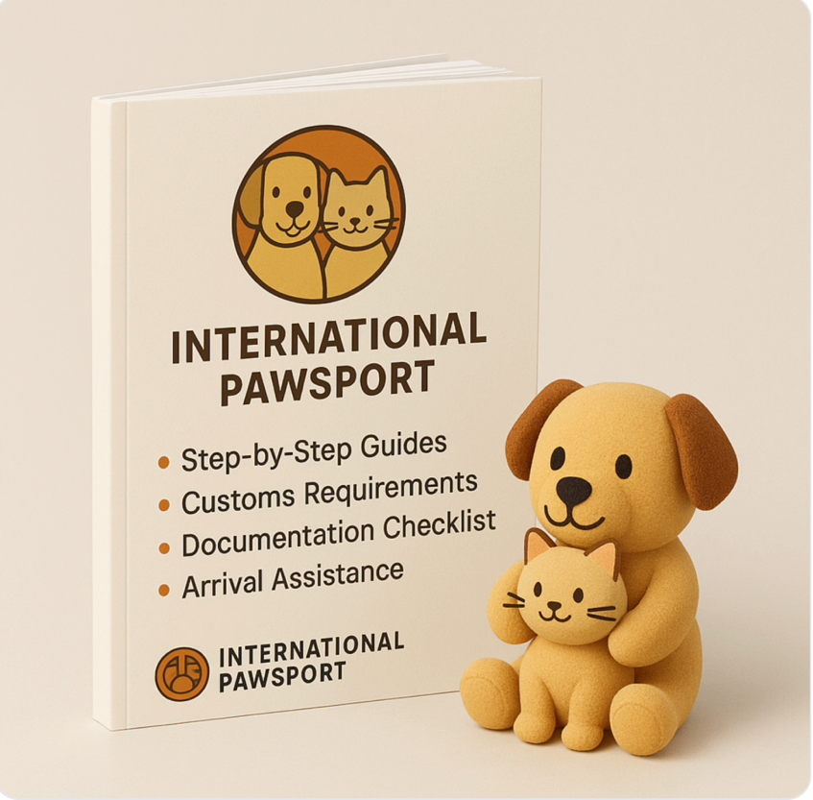

* 1. DIY Digital Pet Moving Assistant\*- $1199/ first pet plus $899 each additional pet
     1. Everything in Pawsport plan plus:
     2. WhatsApp Pet Moving personal assistant to help verify your paperwork
     3. WhatsApp Pet Moving personal assistant to ensure week of move details are ready.
     4. We need to make an image of the above (without the Arrival Assistance line) plus the WHATSAPP logo for the premium product box.
  2. The following text should be in a mandatory checkbox that people have to scroll down through and acknowledge they’ve read before they’re allowed to purchase any product off the website. It should ALSO be placed in the legal section but I can give you more info for both the legal and Terms and Conditions pages in addition to the following:
  3. \*Whiskaway Pets is strictly a DIY service and does not offer in-person assistance. Our services have been designed to include the most up to date information at the time of your purchase. It is the customer’s responsibility to prepare all forms, make all complete payments to government and veterinary personnel on time, and to communicate with your airline, immigration, and pet health experts in order to ensure a smooth travel export/importation experience. Use of this website and our reports constitutes your agreement to these terms in full and you waive all rights to claims against Whiskaway Pets, it’s staff, owners, affiliates, and partners.

1. I will get you more content once structure above is in place for:
   1. Contact
   2. Testimonials
   3. Blog
   4. Benefits of Working with our Team at Whiskaway Pets
   5. FAQs
   6. Legal
   7. Terms and Conditions
2. For the form, I think for now it looks good- let’s make the other changes and then once the site is tweaked we can look to see if there’s a field or 3 missing we really need but thank you for adding the AIRLINE drop down as well.
   1. Please change the label for the AIRLINE field to say ‘ First Choice Airline’
   2. Make 2 more fields for 2nd and 3rd choice Airline
   3. Thanks for fixing the phone field as you wrote you would
   4. I like the ‘Add a Pet’ button- it’s clear
   5. How easy is it to add an interim step with summary after Pet 1 has been completed with the ‘Add a Pet’ near that or just below the summary or the choice of a ‘Edit/Back’ or ‘Add a Pet’ next to ‘Complete Checkout Now’ buttons? If it’s tricky, don’t worry but it would be nice for people to get to a summary page before the checkout page.
   6. Can we add a ‘HOW DID YOU HEAR ABOUT US’ page with a drop down option to choose amongst the following locations where we think we’re going to place ads so we can track where works best:
      1. Facebook ad
      2. Facebook group (which?)
      3. Reddit
      4. Quora
      5. LinkedIn
      6. Instagram
      7. WhatsApp Group (Which?)
      8. Podcast (which?)